**Инструкция для учеников, которые работают с программой «10 ступеней молекулярной грамотности»**

**Как пройти предварительное тестирование?**

1. Запустите MS Internet Explorer

2. В адресной строке наберите адрес сайта тестирования: **http://ri-itest.portal.concord.org**

3. Введите **Username** и **Password** (см. таблицу 1) и щелкните по кнопке **Sign in**

Таблица №1 Список 11а для тестирования

|  |  |  |  |  |
| --- | --- | --- | --- | --- |
|  | **First Name** | **Last Name** | **Username** | **Password** |
| **[setup](http://ri-itest.portal.concord.org/member/edit/27062/)[delete](http://ri-itest.portal.concord.org/class/remove/2289/student/27062/)** | Tonya | Davidova | tonyad | 12345 |
| **[setup](http://ri-itest.portal.concord.org/member/edit/27070/)[delete](http://ri-itest.portal.concord.org/class/remove/2289/student/27070/)** | Maxim | Golodovich | maximg | 12345 |
| **[setup](http://ri-itest.portal.concord.org/member/edit/27064/)[delete](http://ri-itest.portal.concord.org/class/remove/2289/student/27064/)** | Misha | Haenko | mishah | 12345 |
| **[setup](http://ri-itest.portal.concord.org/member/edit/27067/)[delete](http://ri-itest.portal.concord.org/class/remove/2289/student/27067/)** | Maria | Horoshenina | mariah7 | 12345 |
| **[setup](http://ri-itest.portal.concord.org/member/edit/27069/)[delete](http://ri-itest.portal.concord.org/class/remove/2289/student/27069/)** | Ivan | Konushkov | ivank | 12345 |
| **[setup](http://ri-itest.portal.concord.org/member/edit/27074/)[delete](http://ri-itest.portal.concord.org/class/remove/2289/student/27074/)** | Dina | Mankevich | dinam | 12345 |
| **[setup](http://ri-itest.portal.concord.org/member/edit/27072/)[delete](http://ri-itest.portal.concord.org/class/remove/2289/student/27072/)** | Daniel | Mekh | daniilm | 12345 |
| **[setup](http://ri-itest.portal.concord.org/member/edit/27065/)[delete](http://ri-itest.portal.concord.org/class/remove/2289/student/27065/)** | Bogdan | Onischuk | bogdano | 12345 |
| **[setup](http://ri-itest.portal.concord.org/member/edit/27066/)[delete](http://ri-itest.portal.concord.org/class/remove/2289/student/27066/)** | Nikita | Protasevich | nikitap | 12345 |
| **[setup](http://ri-itest.portal.concord.org/member/edit/27071/)[delete](http://ri-itest.portal.concord.org/class/remove/2289/student/27071/)** | Daiil | Slutskiy | daiils | 12345 |
| **[setup](http://ri-itest.portal.concord.org/member/edit/27095/)[delete](http://ri-itest.portal.concord.org/class/remove/2289/student/27095/)** | test | test | testt20 | 12345 |
| **[setup](http://ri-itest.portal.concord.org/member/edit/27063/)[delete](http://ri-itest.portal.concord.org/class/remove/2289/student/27063/)** | Irina | Vlasova | irinav | 12345 |
| **[setup](http://ri-itest.portal.concord.org/member/edit/27068/)[delete](http://ri-itest.portal.concord.org/class/remove/2289/student/27068/)** | Ekaterina | Vorobyova | ekaterinav | 12345 |
| **[setup](http://ri-itest.portal.concord.org/member/edit/27073/)[delete](http://ri-itest.portal.concord.org/class/remove/2289/student/27073/)** | Darya | Yavorskay | daryay | 12345 |
|  | First Name | Last Name | Username | Password |
| **[setup](http://ri-itest.portal.concord.org/member/edit/27252/)[delete](http://ri-itest.portal.concord.org/class/remove/2290/student/27252/)** | Timur | Efremov | timure | 12345 |
| **[setup](http://ri-itest.portal.concord.org/member/edit/27255/)[delete](http://ri-itest.portal.concord.org/class/remove/2290/student/27255/)** | Egor | Nikitin | egorn | 12345 |
| **[setup](http://ri-itest.portal.concord.org/member/edit/27254/)[delete](http://ri-itest.portal.concord.org/class/remove/2290/student/27254/)** | Kirill | Rodin | kirillr | 12345 |
| **[setup](http://ri-itest.portal.concord.org/member/edit/27253/)[delete](http://ri-itest.portal.concord.org/class/remove/2290/student/27253/)** | boris | tsatsulin | borist | 12345 |

3. Если Вы с этого компьютера зашли первый раз, то установите программное обеспечение, щелкнув по **зеленой стрелке** около слов **[info](http://ri-itest.portal.concord.org/)[run](http://ri-itest.portal.concord.org/diy/run/86/)Install/Update Software.** Если установка завершилась успешно, появится сообщение (см. рис.1), которое можно закрыть.

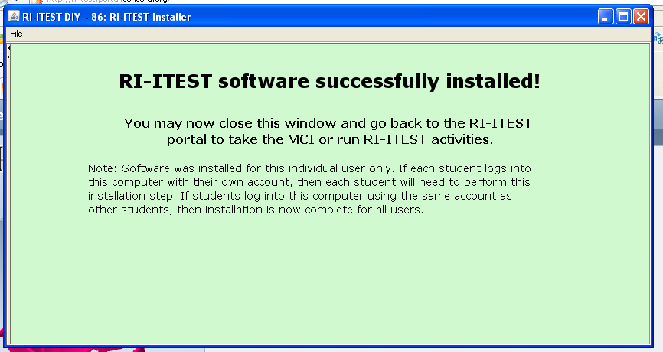

Рис.1

4. Запустите тест, щелкнув по зеленой стрелке **[info](http://ri-itest.portal.concord.org/)[run](http://ri-itest.portal.concord.org/diy/run/94/)[report](http://ri-itest.portal.concord.org/diy/report/217/class/MTFhIC0gMjAxMA==/teacher/R3JlZ29yeSBWb2RvcHlhbg==/members/MTIxMTY=/uuid/NjFjZmQ3ODAtMGFlNS00NDNkLTkxNDMtYWI3Yzc5MDVlZDI1/activity/UGh5c2ljcyBNQ0kgUHJlLVRlc3QgKHYxKQ==/)Physics MCI Pre-Test (v1)**